SEC Form 4

FORM 4

Check this box if no longer subject to Section
- Form 4 or Form 5 obligations may continue. See Instruction 1(b).

Check this box to indicate that a transaction was made pursuant to a contract, instruction or written plan for the purchase or sale of equity securities of the issuer that is intended to satisfy the affirmative defense conditions of Rule 10b5-1(c). See Instruction 10.

UNITED STATES SECURITIES AND EXCHANGE COMMISSION
Washington, D.C. 20549 |  | OMB APPROVAL
STATEMENT OF CHANGES IN BENEFICIAL OWNERSHIP |  | OMB Number: | 3235-0287
STATEMENT OF CHANGES IN BENEFICIAL OWNERSHIP |  | Estimated average burden
Filed pursuant to Section 16(a) of the Securities Exchange Act of 1934 |  | hours per response: | 0.5
or Section 30(h) of the Investment Company Act of 1940
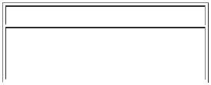
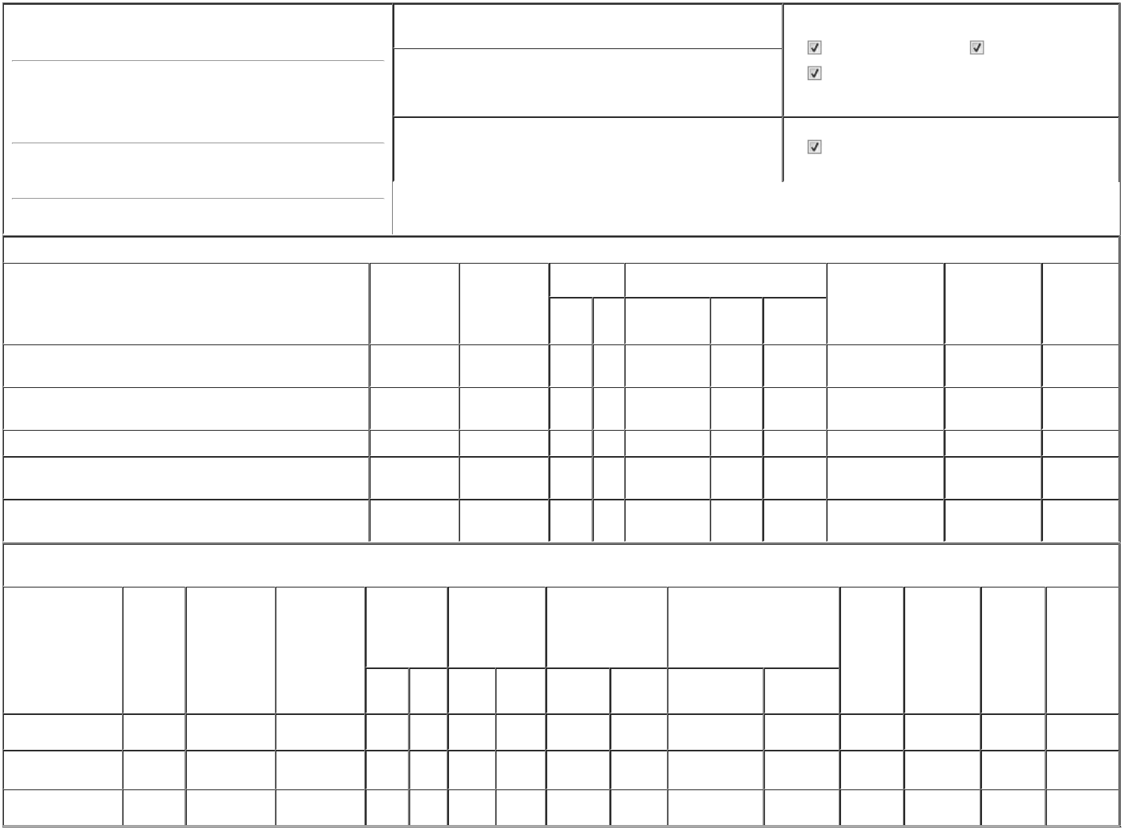

1. Name and Address of Reporting Person * |  |  |  |  |  |  |  |  | 2. Issuer Name and Ticker or Trading Symbol |  |  |  |  |  |  |  |  |  | 5. Relationship of Reporting Person(s) to Issuer
 | Houston Andrew |  |  |  |  |  |  |  | DROPBOX, INC. [ DBX ] |  |  |  |  |  |  |  |  |  | (Check all applicable)
 |  |  |  |  |  |  |  |  |  |  |  |  |  |  |  |  |  |  |  |  |  | Director |  |  | 10% Owner
 |  |  |  |  |  |  |  |  | 3. Date of Earliest Transaction (Month/Day/Year) |  |  |  |  |  |  |  |  |  |  |  |  | Director
 |  |  |  |  |  |  |  |  |  |  |  |  |  |  |  |  |  |  |  |  |  | Officer (give title |  |  | Other (specify below)
 |  |  |  |  |  | 12/03/2025
 | (Last) |  | (First) |  | (Middle) |  |  |  |  |  |  |  |  |  |  |  |  |  |  |  |  | below)
 | 1800 OWENS STREET |  |  |  |  |  |  |  |  |  |  |  |  |  |  |  |  |  |  |  |  | Chief Executive Officer
 | SUITE 200
 | SUITE 200 |  |  |  |  |  |  |  | 4. If Amendment, Date of Original Filed (Month/Day/Year) |  |  |  |  |  |  |  |  |  | 6. Individual or Joint/Group Filing (Check Applicable Line)
 |  |  |  |  |  |  |  |  |  |  |  |  |  |  |  |  |  |  |  |  |  | Form filed by One Reporting Person
(Street)
 |  |  |  |  |  |  |  |  |  |  |  |  |  |  |  |  |  |  |  |  |  | Form filed by More than One Reporting Person
 | SAN FRANCISCO |  | CA |  | 94158
 | (City) |  | (State) |  | (Zip)
 |  |  |  |  | Table I - Non-Derivative Securities Acquired, Disposed of, or Beneficially Owned
1. Title of Security (Instr. 3) |  |  |  |  |  | 2. Transaction |  |  |  | 2A. Deemed |  |  | 3. Transaction |  | 4. Securities Acquired (A) or Disposed Of |  |  |  |  |  | 5. Amount of |  |  | 6. Ownership |  | 7. Nature of
 |  |  |  |  |  | Date |  |  |  | Execution Date, |  |  | Code (Instr. 8) |  | (D) (Instr. 3, 4 and 5) |  |  |  |  |  | Securities Beneficially |  |  | Form: Direct (D) or |  | Indirect
 |  |  |  |  |  | (Month/Day/Year) if any |  |  |  |  |  |  |  |  |  |  |  |  |  |  | Owned Following |  |  | Indirect (I) (Instr. 4) |  | Beneficial
 |  |  |  |  |  |  |  |  |  | (Month/Day/Year) |  |  | CodeV |  | Amount |  | (A) or (D) | Price |  |  | Reported |  |  |  |  | Ownership
 |  |  |  |  |  |  |  |  |  |  |  |  | CodeV |  | Amount |  | (A) or (D) |  |  |  | Transaction(s) (Instr. 3 |  |  |  |  | (Instr. 4)
 |  |  |  |  |  |  |  |  |  |  |  |  |  |  |  |  |  |  |  |  | and 4)
Class A Common Stock |  |  |  |  |  | 12/03/2025 |  |  |  |  |  |  | C |  | 9,167 |  | A | $₀(1) |  |  | 9,167 |  |  |  | I | See
 |  |  |  |  |  |  |  |  |  |  |  |  |  |  |  |  |  |  |  |  |  |  |  |  |  | Footnote(2)
Class A Common Stock |  |  |  |  |  | 12/03/2025 |  |  |  |  |  |  | _{S}(3) |  | 9,167 |  | D | $30 |  |  | 0 |  |  |  | I | See
 |  |  |  |  |  |  |  |  |  |  |  |  |  |  |  |  |  |  |  |  |  |  |  |  |  | Footnote(2)
Class A Common Stock |  |  |  |  |  |  |  |  |  |  |  |  |  |  |  |  |  |  |  |  | 8,266,666(4) |  |  |  | D
Class A Common Stock |  |  |  |  |  |  |  |  |  |  |  |  |  |  |  |  |  |  |  |  | 716,728 |  |  |  | I | See
 |  |  |  |  |  |  |  |  |  |  |  |  |  |  |  |  |  |  |  |  |  |  |  |  | I | Footnote(5)
Class A Common Stock |  |  |  |  |  |  |  |  |  |  |  |  |  |  |  |  |  |  |  |  | 444,444 |  |  |  | I | See
 |  |  |  |  |  |  |  |  |  |  |  |  |  |  |  |  |  |  |  |  |  |  |  |  | I | Footnote(6)
 |  |  |  |  | Table II - Derivative Securities Acquired, Disposed of, or Beneficially Owned
 |  |  |  |  |  | (e.g., puts, calls, warrants, options, convertible securities)
1. Title of Derivative |  | 2. |  | 3. Transaction | 3A. Deemed | 4. Transaction |  |  |  | 5. Number of |  |  | 6. Date Exercisable and |  |  | 7. Title and Amount of Securities |  |  |  |  |  | 8. Price of | 9. Number of |  | 10. | 11. Nature of
Security (Instr. 3) |  | Conversion |  | Date | Execution Date, | Code (Instr. 8) |  |  |  | Derivative |  |  | Expiration Date |  |  | Underlying Derivative Security |  |  |  |  |  | Derivative | derivative |  | Ownership | Indirect
 |  | or Exercise |  | (Month/Day/Year) if any |  |  |  |  |  | Securities |  |  | (Month/Day/Year) |  |  | (Instr. 3 and 4) |  |  |  |  |  | Security | Securities |  | Form: | Beneficial
 |  | Price of |  |  | (Month/Day/Year) |  |  |  |  | Acquired (A) or |  |  |  |  |  |  |  |  |  |  |  | (Instr. 5) | Beneficially |  | Direct (D) or | Ownership
 |  | Derivative |  |  |  |  |  |  |  | Disposed of (D) |  |  |  |  |  |  |  |  |  |  |  |  | Owned |  | Indirect (I) | (Instr. 4)
 |  | Security |  |  |  |  |  |  |  | (Instr. 3, 4 and 5) |  |  |  |  |  |  |  |  |  |  |  |  | Following |  | (Instr. 4)
 |  |  |  |  |  |  |  |  |  |  |  |  |  |  |  |  |  |  |  |  |  |  | Reported
 |  |  |  |  |  |  |  |  |  |  |  |  |  |  |  |  |  | Amount or
 |  |  |  |  |  |  |  |  |  |  |  |  |  |  |  |  |  |  |  |  |  |  | Transaction(s)
 |  |  |  |  |  |  |  |  |  |  |  |  | Date | Expiration |  |  |  | Number of |  |  |  |  | (Instr. 4)
 |  |  |  |  |  | CodeV |  |  |  | (A) | (D) |  | Exercisable | Date |  | Title |  | Shares
Class B Common Stock |  | (7) |  | 12/03/2025 |  | C |  |  |  |  | 9,167 |  | (7) |  | (7) | Class A Common |  | 9,167 |  |  | $0 |  | 66,934,293 |  | I | See foonote⁽²⁾
 |  |  |  | 12/03/2025 |  |  |  |  |  |  |  |  | (7) |  | (7) |  | Stock
Class B Common Stock |  | (7) |  |  |  |  |  |  |  |  |  |  | (7) |  | (7) | Class A Common |  | 7,608,764 |  |  |  |  | 7,608,764 |  | I | See
 |  |  |  |  |  |  |  |  |  |  |  |  | (7) |  | (7) |  | Stock |  |  |  |  |  |  |  | I | Footnote⁽⁵⁾
Class B Common Stock |  | (7) |  |  |  |  |  |  |  |  |  |  | (7) |  | (7) | Class A Common |  | 500,500 |  |  |  |  | 500,500 |  | I | See foonote⁽⁸⁾
 |  |  |  |  |  |  |  |  |  |  |  |  | (7) |  | (7) |  | Stock |  |  |  |  |  |  |  | I | See foonote⁽⁸⁾

Explanation of Responses:

- 9,167 shares of Class B Common Stock were converted into 9,167 shares of Class A Common Stock at the election of the Reporting Person and had no expiration date.

- Shares held by the Andrew Houston Revocable Trust u/a/d 9/7/2011, for which Reporting Person serves as trustee.

- These shares were sold pursuant to a Rule 10b5-1 trading plan adopted by the Reporting Person on March 12, 2025.

- These securities are restricted stock awards of Class A Common Stock. The restricted stock awards vest over a period of up to ten years following the closing of the Issuer's initial public offering of Class A Common Stock, or March 27, 2028, upon achievement of service-based, market-based, and liquidity event-related performance vesting conditions.

- Shares held by the Houston Remainder Trust u/a/d 12/30/2010, for which Reporting Person serves as trustee.

- Shares held by The Erin Yu Houston Revocable Trust u/a/d 1/18/2024, for which the Reporting Person's spouse serves as trustee.

- The Issuer's Class B Common Stock is convertible into the Issuer's Class A Common Stock on a one-for-one basis at the Reporting Person's election and has no expiration date.

- Shares held by the Houston 2012 Irrevocable Children's Trust u/a/d 4/12/2012, for which Reporting Person serves as trustee.

Remarks:

 | /s/ Cara Angelmar, Attorney-in-Fact |  | 12/05/2025
 | ** Signature of Reporting Person |  | Date
Reminder: Report on a separate line for each class of securities beneficially owned directly or indirectly.
* If the form is filed by more than one reporting person, see Instruction 4 (b)(v).
** Intentional misstatements or omissions of facts constitute Federal Criminal Violations See 18 U.S.C. 1001 and 15 U.S.C. 78ff(a).
Note: File three copies of this Form, one of which must be manually signed. If space is insufficient, see Instruction 6 for procedure.
Persons who respond to the collection of information contained in this form are not required to respond unless the form displays a currently valid OMB Number.



