SEC Form 4
FORM 4 |  | UNITED STATES SECURITIES AND EXCHANGE COMMISSION  Washington, D.C. 20549  STATEMENT OF CHANGES IN BENEFICIAL OWNERSHIP  Filed pursuant to Section 16(a) of the Securities Exchange Act of 1934  or Section 30(h) of the Investment Company Act of 1940
  OMB APPROVAL
  OMB Number: | 3235-0287
  Estimated average burden
  hours per response: | 0.5
 | Check this box if no longer subject to Section 16. Form 4 or Form 5 obligations may continue. See Instruction 1(b).
 | Check this box to indicate that a transaction was made pursuant to a contract, instruction or written plan for the purchase or sale of equity securities of the issuer that is intended to satisfy the affirmative defense conditions of Rule 10b5-1(c). See Instruction 10.
1. Name and Address of Reporting Person*  (Street) | 2. Issuer Name and Ticker or Trading Symbol  DROPBOX, INC. [ DBX ] | 5. Relationship of Reporting Person(s) to Issuer  (Check all applicable)
  Houston Andrew
  (Last) | (First) | (Middle)
  1800 OWENS STREET
  SUITE 200
  SAN FRANCISCO | CA | 94158
  (City) | (State) | (Zip)
   | Director |  | 10% Owner
   | Officer (give title below) |  | Other (specify below)
  Chief Executive Officer
3. Date of Earliest Transaction (Month/Day/Year)
10/01/2025
 | 4. If Amendment, Date of Original Filed (Month/Day/Year) | 6. Individual or Joint/Group Filing (Check Applicable Line)
  Form filed by One Reporting Person
  Form filed by More than One Reporting Person
Table I - Non-Derivative Securities Acquired, Disposed of, or Beneficially Owned
1. Title of Security (Instr. 3) | 2. Transaction Date (Month/Day/Year) | 2A. Deemed Execution Date, if any (Month/Day/Year) | 3. Transaction Code (Instr. 8) |  | 4. Securities Acquired (A) or Disposed Of (D) (Instr. 3, 4 and 5) |  |  | 5. Amount of Securities Beneficially Owned Following Reported Transaction(s) (Instr. 3 and 4) | 6. Ownership Form: Direct (D) or Indirect (I) (Instr. 4) | 7. Nature of Indirect Beneficial Ownership (Instr. 4)
1. Title of Security (Instr. 3) | 2. Transaction Date (Month/Day/Year) | 2A. Deemed Execution Date, if any (Month/Day/Year) | Code | V | Amount | (A) or (D) | Price |  | 6. Ownership Form: Direct (D) or Indirect (I) (Instr. 4) | 7. Nature of Indirect Beneficial Ownership (Instr. 4)
Class A Common Stock | 10/01/2025 |  | C |  | 101,167 | A | $0(1) | 101,167 | I | See Footnote(2)
Class A Common Stock | 10/01/2025 |  | S(3) |  | 97,616 | D | $29.6218(4) | 3,551 | I | See Footnote(2)
Class A Common Stock | 10/01/2025 |  | S(3) |  | 3,551 | D | $30.2209(5) | 0 | I | See Footnote(2)
Class A Common Stock |  |  |  |  |  |  |  | 8,266,666(6) | D
Class A Common Stock |  |  |  |  |  |  |  | 716,728 | I | See Footnote(7)
Class A Common Stock |  |  |  |  |  |  |  | 444,444 | I | See Footnote(8)
Table II - Derivative Securities Acquired, Disposed of, or Beneficially Owned
(e.g., puts, calls, warrants, options, convertible securities)
1. Title of Derivative Security (Instr. 3) | 2. Conversion or Exercise Price of Derivative Security | 3. Transaction Date (Month/Day/Year) | 3A. Deemed Execution Date, if any (Month/Day/Year) | 4. Transaction Code (Instr. 8) |  | 5. Number of Derivative Securities Acquired (A) or Disposed of (D) (Instr. 3, 4 and 5) |  | 6. Date Exercisable and Expiration Date (Month/Day/Year) |  | 7. Title and Amount of Securities Underlying Derivative Security (Instr. 3 and 4) |  | 8. Price of Derivative Security (Instr. 5) | 9. Number of derivative Securities Beneficially Owned Following Reported Transaction(s) (Instr. 4) | 10. Ownership Form: Direct (D) or Indirect (I) (Instr. 4) | 11. Nature of Indirect Beneficial Ownership (Instr. 4)
 |  |  |  | Code | V | (A) | (D) | Date Exercisable | Expiration Date | Title | Amount or Number of Shares
Class B Common Stock | (9) | 10/01/2025 |  | C |  |  | 101,167 | (9) | (9) | Class A Common Stock | 101,167 | $0 | 67,136,627 | I | See foonote(2)
Class B Common Stock | (9) |  |  |  |  |  |  | (9) | (9) | Class A Common Stock | 7,608,764 |  | 7,608,764 | I | See Footnote(10)
Class B Common Stock | (9) |  |  |  |  |  |  | (9) | (9) | Class A Common Stock | 500,500 |  | 500,500 | I | See foonote(11)
Explanation of Responses:
1. 101,167 shares of Class B Common Stock were converted into 101,167 shares of Class A Common Stock at the election of the Reporting Person and had no expiration date.
2. Shares held by the Andrew Houston Revocable Trust u/a/d 9/7/2011, for which Reporting Person serves as trustee.
3. These shares were sold pursuant to a Rule 10b5-1 trading plan adopted by the Reporting Person on March 12, 2025.
4. This transaction was executed in multiple trades at prices ranging from $29.13 to $30.12. The price reported above reflects the weighted average sale price. The Reporting Person hereby undertakes to provide upon request to the SEC staff, the issuer or a security holder of the issuer full information regarding the number of shares and prices at which the transaction was effected.
5. This transaction was executed in multiple trades at prices ranging from $30.13 to $30.34. The price reported above reflects the weighted average sale price. The Reporting Person hereby undertakes to provide upon request to the SEC staff, the issuer or a security holder of the issuer full information regarding the number of shares and prices at which the transaction was effected.
6. These securities are restricted stock awards of Class A Common Stock. The restricted stock awards vest over a period of up to ten years following the closing of the Issuer's initial public offering of Class A Common Stock, or March 27, 2028, upon achievement of service-based, market-based, and liquidity event-related performance vesting conditions.
7. Shares held by the Houston Remainder Trust u/a/d 12/30/2010, for which reporting Person serves as trustee.
8. Shares held by The Erin Yu Houston Revocable Trust u/a/d 1/18/2024, for which the Reporting Person's spouse serves as trustee.
9. The Issuer's Class B Common Stock is convertible into the Issuer's Class A Common Stock on a one-for-one basis at the Reporting Person's election and has no expiration date.
10. Shares held by the Houston Remainder Trust u/a/d 12/30/2010, for which Reporting Person serves as trustee.
11. Shares held by the Houston 2012 Irrevocable Children's Trust u/a/d 4/12/2012, for which Reporting Person serves as trustee.
Remarks:
 | /s/ Cara Angelmar, Attorney-in-Fact | 10/03/2025
 | ** Signature of Reporting Person | Date
Reminder: Report on a separate line for each class of securities beneficially owned directly or indirectly.
* If the form is filed by more than one reporting person, see Instruction 4 (b)(v).
** Intentional misstatements or omissions of facts constitute Federal Criminal Violations See 18 U.S.C. 1001 and 15 U.S.C. 78ff(a).
Note: File three copies of this Form, one of which must be manually signed. If space is insufficient, see Instruction 6 for procedure.
Persons who respond to the collection of information contained in this form are not required to respond unless the form displays a currently valid OMB Number.
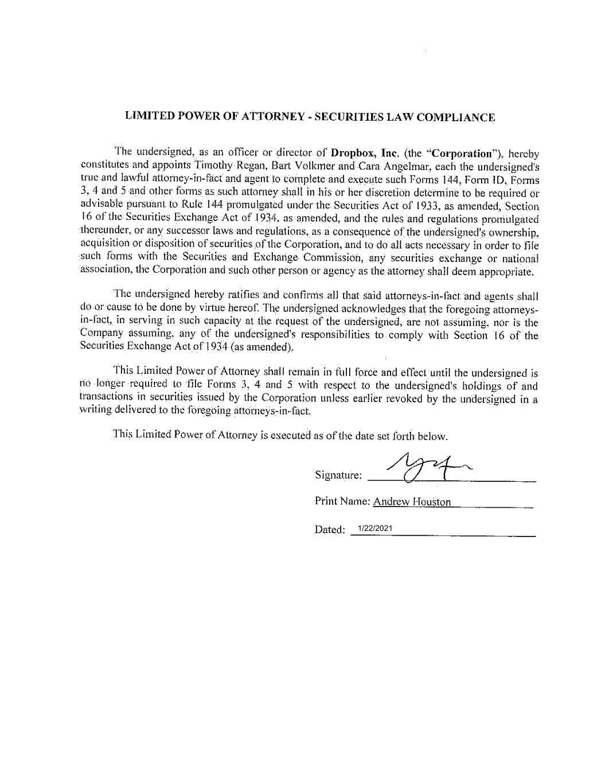
1/22/2021

