SEC Form 4

FORM 4

Check this box if no longer subject to Section 16. Form 4 or Form 5 obligations may continue. See Instruction 1(b).

UNITED STATES SECURITIES AND EXCHANGE COMMISSION
Washington, D.C. 20549
 |  | OMB APPROVAL
STATEMENT OF CHANGES IN BENEFICIAL OWNERSHIP
 |  | OMB Number: | 3235-0287
 |  | Estimated average burden
Filed pursuant to Section 16(a) of the Securities Exchange Act of 1934 |  | hours per response: | 0.5
or Section 30(h) of the Investment Company Act of 1940
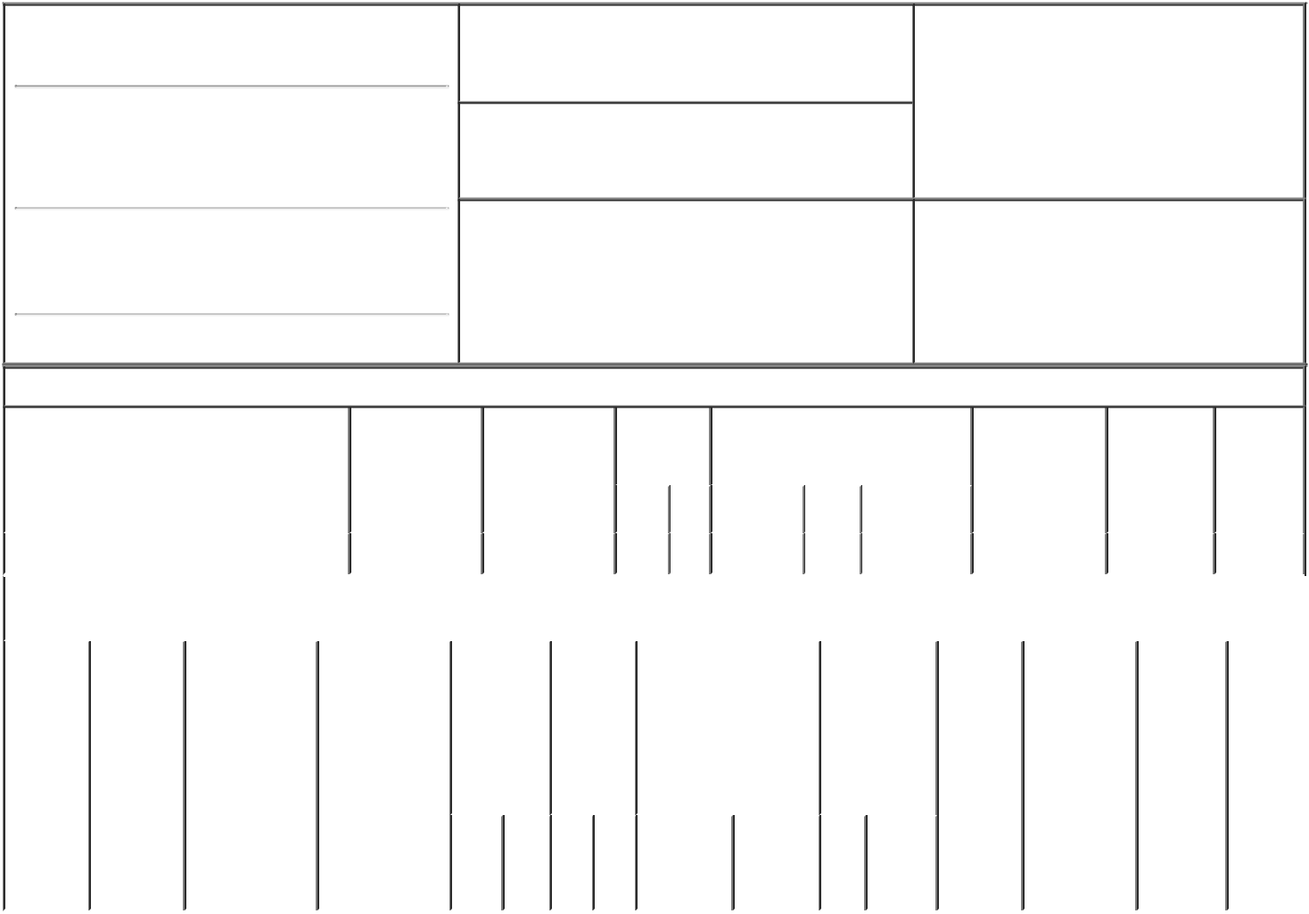

1. Name and Address of Reporting Person*
Regan Timothy

(Last) (First) (Middle)

1800 OWENS STREET

SUITE 200

2. Issuer Name and Ticker or Trading Symbol

DROPBOX, INC. [ DBX ]

3. Date of Earliest Transaction (Month/Day/Year)

01/25/2023

- Relationship of Reporting Person(s) to Issuer (Check all applicable)

 | Director | 10% Owner
X | Officer (give title | Other (specify
 | below) | below)

Chief Financial Officer

(Street)

^{SAN} CA 94158 FRANCISCO

(City) (State) (Zip)

4. If Amendment, Date of Original Filed (Month/Day/Year) 6. Individual or Joint/Group Filing (Check Applicable

Line)

X Form filed by One Reporting Person

Form filed by More than One Reporting

Person

Table I - Non-Derivative Securities Acquired, Disposed of, or Beneficially Owned

 | 1. Title of Security (Instr. 3) |  |  | 2. Transaction |  | 2A. Deemed |  |  | 3. |  | 4. Securities Acquired (A) or |  |  |  |  | 5. Amount of |  | 6. Ownership | 7. Nature
 |  |  |  | Date |  | Execution Date, |  |  | Transaction |  | Disposed Of (D) (Instr. 3, 4 and 5) |  |  |  |  | Securities |  | Form: Direct | of Indirect
 |  |  |  | (Month/Day/Year) if any |  |  |  |  | Code (Instr. |  |  |  |  |  |  | Beneficially |  | (D) or | Beneficial
 |  |  |  |  |  | (Month/Day/Year) |  |  | 8) |  |  |  |  |  |  | Owned Following |  | Indirect (I) | Ownership
 |  |  |  |  |  |  |  |  |  |  |  |  |  |  |  | Reported |  | (Instr. 4) | (Instr. 4)
 |  |  |  |  |  |  |  |  | Code V |  | Amount | (A) or | Price |  |  | Transaction(s)
 |  |  |  |  |  |  |  |  |  |  |  | (D) |  |  |  | (Instr. 3 and 4)
 | Class A Common Stock |  |  | 01/25/2023 |  |  |  |  | _{S}(1) |  | 2,369 | D | $22.8214⁽²⁾ |  |  | 466,230⁽³⁾ |  | D
 |  |  | Table II - Derivative Securities Acquired, Disposed of, or Beneficially Owned
 |  |  |  | (e.g., puts, calls, warrants, options, convertible securities)
 | 1. Title of | 2. | 3. Transaction | 3A. Deemed |  | 4. | 5. Number |  |  | 6. Date Exercisable and |  | 7. Title and |  |  | 8. Price of |  | 9. Number of 10. |  | 11. Nature
 | Derivative | Conversion | Date | Execution Date, |  | Transaction | of |  |  | Expiration Date |  | Amount of |  |  | Derivative |  | derivative | Ownership | of Indirect
 | Security | or Exercise | (Month/Day/Year) | if any |  | Code (Instr. | Derivative |  |  | (Month/Day/Year) |  | Securities |  |  | Security |  | Securities | Form: | Beneficial
 | (Instr. 3) | Price of |  | (Month/Day/Year) |  | 8) | Securities |  |  |  |  | Underlying |  |  | (Instr. 5) |  | Beneficially | Direct (D) | Ownership
 |  | Derivative |  |  |  |  | Acquired |  |  |  |  | Derivative |  |  |  |  | Owned | or Indirect | (Instr. 4)
 |  | Security |  |  |  |  | (A) or |  |  |  |  | Security (Instr. |  |  |  |  | Following | (I) (Instr. 4)
 |  |  |  |  |  |  | Disposed |  |  |  |  | 3 and 4) |  |  |  |  | Reported
 |  |  |  |  |  |  | of (D) |  |  |  |  |  |  |  |  |  | Transaction(s)
 |  |  |  |  |  |  | (Instr. 3, 4 |  |  |  |  |  |  |  |  |  | (Instr. 4)
 |  |  |  |  |  |  | and 5)
 |  |  |  |  |  |  |  |  |  |  |  |  | Amount
 |  |  |  |  |  |  |  |  |  |  |  |  | or
 |  |  |  |  |  |  |  |  |  |  |  |  | Number
 |  |  |  |  |  |  |  |  |  | Date | Expiration |  | of
 |  |  |  |  |  | Code V | (A) (D) |  |  | Exercisable Date |  | Title | Shares

Explanation of Responses:

- These shares were sold pursuant to a Rule 10b5-1 trading plan entered into by the Reporting Person.

- This transaction was executed in multiple trades at prices ranging from $22.63 to $22.97. The price reported above reflects the weighted average sale price. The Reporting Person hereby undertakes to provide upon request to the SEC staff, the issuer or a security holder of the issuer full information regarding the number of shares and prices at which the transaction was effected.

- Certain of these securities are restricted stock awards and restricted stock units. Each restricted stock award or restricted stock unit represents the Reporting Person's right to receive one share of Class A Common Stock, subject to the applicable vesting schedule through February 15, 2026. In the event the Reporting Person ceases to be a Service Provider, the unvested restricted stock awards and restricted stock units will be cancelled by the Issuer.

Remarks:

/s/ Cara Angelmar, Attorney- |  |  | 01/27/2023
in-Fact
** Signature of Reporting Person |  |  | Date

Reminder: Report on a separate line for each class of securities beneficially owned directly or indirectly.

* If the form is filed by more than one reporting person, see Instruction 4 (b)(v).

- Intentional misstatements or omissions of facts constitute Federal Criminal Violations See 18 U.S.C. 1001 and 15 U.S.C. 78ff(a). Note: File three copies of this Form, one of which must be manually signed. If space is insufficient, see Instruction 6 for procedure.

Persons who respond to the collection of information contained in this form are not required to respond unless the form displays a currently valid OMB Number.

LIMITED POWER OF ATTORNEY - SECURITIES LAW COMPLIANCE

The undersigned, as an officer or director of Dropbox, Inc. (the "Corporation"), hereby constitutes and appoints Bart Volkmer and Cara Angelmar, each the undersigned's true and lawful attorney-in-fact and agent to complete and execute such Forms 144, Form ID, Forms 3, 4 and 5 and other forms as such attorney shall in his or her discretion determine to be required or advisable pursuant to Rule 144 promulgated under the Securities Act of 1933, as amended, Section 16 of the Securities Exchange Act of 1934, as amended, and the rules and regulations promulgated thereunder, or any successor laws and regulations, as a consequence of the undersigned's ownership, acquisition or disposition of securities of the Corporation, and to do all acts necessary in order to file such forms with the Securities and Exchange Commission, any securities exchange or national association, the Corporation and such other person or agency as the attorney shall deem appropriate.

The undersigned hereby ratifies and confirms all that said attorneys-in-fact and agents shall do or cause to be done by virtue hereof. The undersigned acknowledges that the foregoing attorneys-in-fact, in serving in such capacity at the request of the undersigned, are not assuming, nor is the Company assuming, any of the undersigned's responsibilities to comply with Section 16 of the Securities Exchange Act of 1934 (as amended).

This Limited Power of Attorney shall remain in full force and effect until the undersigned is no longer required to file Forms 3, 4 and 5 with respect to the undersigned's holdings of and transactions in securities issued by the Corporation unless earlier revoked by the undersigned in a writing delivered to the foregoing attorneys-in-fact.

This Limited Power of Attorney is executed as of the date set forth below.

Signature: /s/ Timothy Regan

Print Name: Timothy Regan

Dated: 1/25/2021

