SEC Form 4
FORM 4 |  | UNITED STATES SECURITIES AND EXCHANGE COMMISSION  Washington, D.C. 20549  STATEMENT OF CHANGES IN BENEFICIAL OWNERSHIP  Filed pursuant to Section 16(a) of the Securities Exchange Act of 1934  or Section 30(h) of the Investment Company Act of 1940
  OMB APPROVAL
  OMB Number: | 3235-0287
  Estimated average burden
  hours per response: | 0.5
 | Check this box if no longer subject to Section 16. Form 4 or Form 5 obligations may continue. See Instruction 1(b).
 | Check this box to indicate that a transaction was made pursuant to a contract, instruction or written plan for the purchase or sale of equity securities of the issuer that is intended to satisfy the affirmative defense conditions of Rule 10b5-1(c). See Instruction 10.
1. Name and Address of Reporting Person*  (Street) | 2. Issuer Name and Ticker or Trading Symbol  DROPBOX, INC. [ DBX ] | 5. Relationship of Reporting Person(s) to Issuer  (Check all applicable)
  Parasnis Abhay
  (Last) | (First) | (Middle)
  1800 OWENS STREET
  SUITE 200
  SAN FRANCISCO | CA | 94158
  (City) | (State) | (Zip)
   | Director |  | 10% Owner
   | Officer (give title below) |  | Other (specify below)
3. Date of Earliest Transaction (Month/Day/Year)
08/20/2025
 | 4. If Amendment, Date of Original Filed (Month/Day/Year) | 6. Individual or Joint/Group Filing (Check Applicable Line)
  Form filed by One Reporting Person
  Form filed by More than One Reporting Person
Table I - Non-Derivative Securities Acquired, Disposed of, or Beneficially Owned
1. Title of Security (Instr. 3) | 2. Transaction Date (Month/Day/Year) | 2A. Deemed Execution Date, if any (Month/Day/Year) | 3. Transaction Code (Instr. 8) |  | 4. Securities Acquired (A) or Disposed Of (D) (Instr. 3, 4 and 5) |  |  | 5. Amount of Securities Beneficially Owned Following Reported Transaction(s) (Instr. 3 and 4) | 6. Ownership Form: Direct (D) or Indirect (I) (Instr. 4) | 7. Nature of Indirect Beneficial Ownership (Instr. 4)
1. Title of Security (Instr. 3) | 2. Transaction Date (Month/Day/Year) | 2A. Deemed Execution Date, if any (Month/Day/Year) | Code | V | Amount | (A) or (D) | Price |  | 6. Ownership Form: Direct (D) or Indirect (I) (Instr. 4) | 7. Nature of Indirect Beneficial Ownership (Instr. 4)
Class A Common Stock | 08/20/2025 |  | S(1) |  | 3,564 | D | $28.26 | 40,522(2) | D
Table II - Derivative Securities Acquired, Disposed of, or Beneficially Owned
(e.g., puts, calls, warrants, options, convertible securities)
1. Title of Derivative Security (Instr. 3) | 2. Conversion or Exercise Price of Derivative Security | 3. Transaction Date (Month/Day/Year) | 3A. Deemed Execution Date, if any (Month/Day/Year) | 4. Transaction Code (Instr. 8) |  | 5. Number of Derivative Securities Acquired (A) or Disposed of (D) (Instr. 3, 4 and 5) |  | 6. Date Exercisable and Expiration Date (Month/Day/Year) |  | 7. Title and Amount of Securities Underlying Derivative Security (Instr. 3 and 4) |  | 8. Price of Derivative Security (Instr. 5) | 9. Number of derivative Securities Beneficially Owned Following Reported Transaction(s) (Instr. 4) | 10. Ownership Form: Direct (D) or Indirect (I) (Instr. 4) | 11. Nature of Indirect Beneficial Ownership (Instr. 4)
 |  |  |  | Code | V | (A) | (D) | Date Exercisable | Expiration Date | Title | Amount or Number of Shares
Explanation of Responses:
1. These shares were sold pursuant to a Rule 10b5-1 trading plan adopted by the Reporting Person on May 21, 2025.
2. Certain of these securities are restricted stock units. Each restricted stock unit represents the Reporting Person's right to receive one share of Class A Common Stock, subject to the applicable vesting schedule through May 15, 2026 or the day prior to the date of the Issuer's next annual meeting of stockholders. In the event the Reporting Person ceases to be a Service Provider, the unvested restricted stock units will be cancelled by the Issuer.
Remarks:
 | /s/ Cara Angelmar, Attorney-in-Fact | 08/22/2025
 | ** Signature of Reporting Person | Date
Reminder: Report on a separate line for each class of securities beneficially owned directly or indirectly.
* If the form is filed by more than one reporting person, see Instruction 4 (b)(v).
** Intentional misstatements or omissions of facts constitute Federal Criminal Violations See 18 U.S.C. 1001 and 15 U.S.C. 78ff(a).
Note: File three copies of this Form, one of which must be manually signed. If space is insufficient, see Instruction 6 for procedure.
Persons who respond to the collection of information contained in this form are not required to respond unless the form displays a currently valid OMB Number.
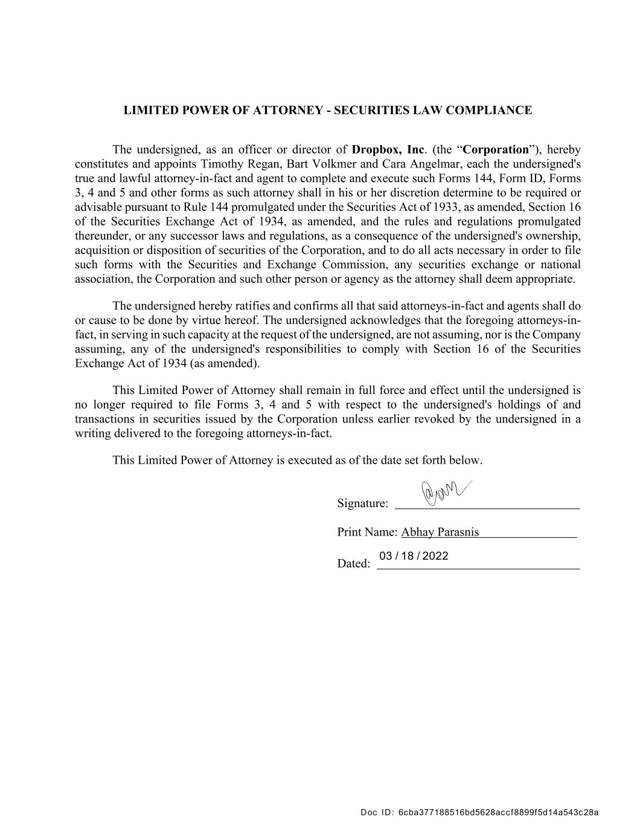
LIMITED POWER OF ATTORNEY - SECURITIES LAW COMPLIANCE The undersigned, as an officer or director of Dropbox, Inc. (the “Corporation”), hereby constitutes and appoints Timothy Regan, Bart Volkmer and Cara Angelmar, each the undersigned's true and lawful attorney-in-fact and agent to complete and execute such Forms 144, Form ID, Forms 3, 4 and 5 and other forms as such attorney shall in his or her discretion determine to be required or advisable pursuant to Rule 144 promulgated under the Securities Act of 1933, as amended, Section 16 of the Securities Exchange Act of 1934, as amended, and the rules and regulations promulgated thereunder, or any successor laws and regulations, as a consequence of the undersigned's ownership, acquisition or disposition of securities of the Corporation, and to do all acts necessary in order to file such forms with the Securities and Exchange Commission, any securities exchange or national association, the Corporation and such other person or agency as the attorney shall deem appropriate. The undersigned hereby ratifies and confirms all that said attorneys-in-fact and agents shall do or cause to be done by virtue hereof. The undersigned acknowledges that the foregoing attorneys-in- fact, in serving in such capacity at the request of the undersigned, are not assuming, nor is the Company assuming, any of the undersigned's responsibilities to comply with Section 16 of the Securities Exchange Act of 1934 (as amended). This Limited Power of Attorney shall remain in full force and effect until the undersigned is no longer required to file Forms 3, 4 and 5 with respect to the undersigned's holdings of and transactions in securities issued by the Corporation unless earlier revoked by the undersigned in a writing delivered to the foregoing attorneys-in-fact. This Limited Power of Attorney is executed as of the date set forth below. Signature: Print Name: Abhay Parasnis Dated: 03 / 18 / 2022 Doc ID: 6cba377188516bd5628accf8899f5d14a543c28a

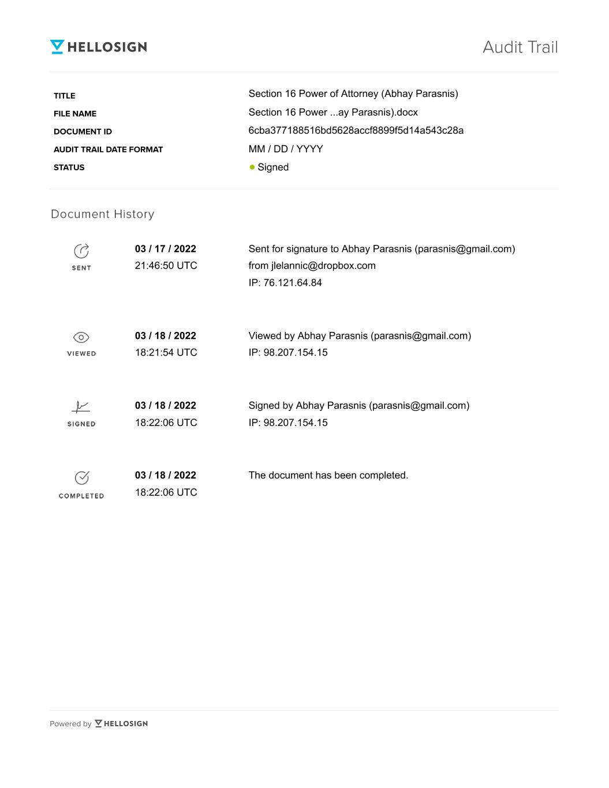
Audit Trail Title File Name Document ID Audit Trail Date Format Status Section 16 Power of Attorney (Abhay Parasnis) Section 16 Power ...ay Parasnis).docx 6cba377188516bd5628accf8899f5d14a543c28a MM / DD / YYYY Signed 03 / 17 / 2022 21:46:50 UTC Sent for signature to Abhay Parasnis (parasnis@gmail.com) from jlelannic@dropbox.com IP: 76.121.64.84 03 / 18 / 2022 18:21:54 UTC Viewed by Abhay Parasnis (parasnis@gmail.com) IP: 98.207.154.15 03 / 18 / 2022 18:22:06 UTC Signed by Abhay Parasnis (parasnis@gmail.com) IP: 98.207.154.15 The document has been completed.03 / 18 / 2022 18:22:06 UTC

