SEC Form 4

FORM 4

Check this box if no longer subject to Section 16. Form 4 or Form 5 obligations may continue. See Instruction 1(b).

Check this box to indicate that a transaction was made pursuant to a contract, instruction or written plan for the purchase or sale of equity securities of the issuer that is intended to satisfy the affirmative defense conditions of Rule 10b5-1(c). See Instruction 10.

UNITED STATES SECURITIES AND EXCHANGE COMMISSION
Washington, D.C. 20549
Washington, D.C. 20549 |  | OMB APPROVAL
STATEMENT OF CHANGES IN BENEFICIAL OWNERSHIP
STATEMENT OF CHANGES IN BENEFICIAL OWNERSHIP |  | OMB Number: | 3235-0287
 |  | Estimated average burden
Filed pursuant to Section 16(a) of the Securities Exchange Act of 1934 |  | hours per response: | 0.5
or Section 30(h) of the Investment Company Act of 1940
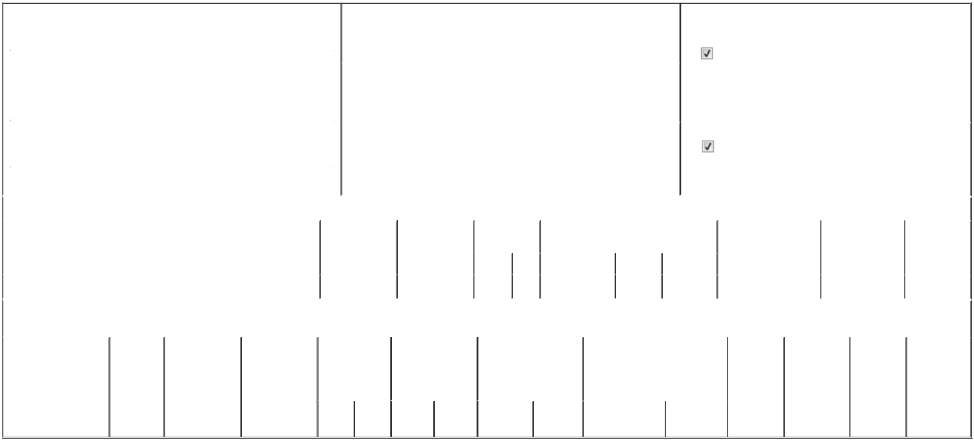

 | 1. Name and Address of Reporting Person* |  |  |  |  |  |  |  |  | 2. Issuer Name and Ticker or Trading Symbol |  |  |  |  |  |  |  |  |  | 5. Relationship of Reporting Person(s) to Issuer
 |  | Cox Eric |  |  |  |  |  |  |  | DROPBOX, INC. [ DBX ] |  |  |  |  |  |  |  |  |  | (Check all applicable)
 |  | Cox Eric |  |  |  |  |  |  |  |  |  |  |  |  |  |  |  |  |  |  |  | Director |  |  | 10% Owner
 |  |  |  |  |  |  |  |  |  |  |  |  |  |  |  |  |  |  |  |  |  | Officer (give title |  |  | Other (specify below)
 |  |  |  |  |  |  |  |  |  |  |  |  |  |  |  |  |  |  |  |  |  | below)
 |  | (Last) |  | (First) |  | (Middle) |  |  |  |  |  |  |  |  |  |  |  |  |  |  |  | below)
 |  |  |  | (First) |  | (Middle) |  |  |  | 3. Date of Earliest Transaction (Month/Day/Year) |  |  |  |  |  |  |  |  |  |  |  | Chief Customer Officer
 |  | 1800 OWENS STREET
 |  |  |  |  |  |  | 04/01/2025
 |  | SUITE 200
 | (Street) |  |  |  |  |  |  |  |  | 4. If Amendment, Date of Original Filed (Month/Day/Year) |  |  |  |  |  |  |  |  |  | 6. Individual or Joint/Group Filing (Check Applicable Line)
 |  | SAN FRANCISCO |  | CA |  | 94158 | 04/03/2025 |  |  |  |  |  |  |  |  |  |  |  |  |  |  | Form filed by One Reporting Person
 |  |  |  |  |  |  |  |  |  |  |  |  |  |  |  |  |  |  |  |  |  | Form filed by More than One Reporting Person
 |  | (City) |  | (State) |  | (Zip)
 |  |  |  |  |  | Table I - Non-Derivative Securities Acquired, Disposed of, or Beneficially Owned
 | 1. Title of Security (Instr. 3) |  |  |  |  |  | 2. Transaction |  |  |  | 2A. Deemed |  |  | 3. Transaction |  | 4. Securities Acquired (A) or Disposed Of |  |  |  |  | 5. Amount of Securities |  |  | 6. Ownership |  | 7. Nature of
 |  |  |  |  |  |  | Date |  |  |  | Execution Date, |  |  | Code (Instr. 8) (D) (Instr. 3, 4 and 5) |  |  |  |  |  |  | Beneficially Owned |  |  | Form: Direct (D) or |  | Indirect
 |  |  |  |  |  |  | (Month/Day/Year) |  |  |  | if any |  |  |  |  |  |  |  |  |  | Following Reported |  |  | Indirect (I) (Instr. 4) |  | Beneficial
 |  |  |  |  |  |  |  |  |  |  | (Month/Day/Year) |  |  | Code | V | Amount |  | (A) or (D) | Price |  | Transaction(s) (Instr. 3 |  |  |  |  | Ownership
 |  |  |  |  |  |  |  |  |  |  |  |  |  | Code | V | Amount |  | (A) or (D) |  |  | and 4) |  |  |  |  | (Instr. 4)
 | Class A Common Stock |  |  |  |  |  | 04/01/2025 |  |  |  |  |  |  | A |  | 83,910⁽¹⁾ |  | A | $0 |  | 393,460⁽²⁾⁽³⁾ |  |  |  | D
 |  |  |  |  |  | Table II - Derivative Securities Acquired, Disposed of, or Beneficially Owned
 |  |  |  |  |  |  | (e.g., puts, calls, warrants, options, convertible securities)
 | 1. Title of Derivative |  |  | 2. | 3. Transaction | 3A. Deemed | 4. Transaction |  |  |  | 5. Number of |  |  | 6. Date Exercisable and |  |  | 7. Title and Amount of Securities |  |  |  |  | 8. Price of | 9. Number of |  | 10. | 11. Nature of
 | Security (Instr. 3) |  |  | Conversion | Date | Execution Date, | Code (Instr. 8) |  |  |  | Derivative |  |  | Expiration Date |  |  | Underlying Derivative Security |  |  |  |  | Derivative | derivative |  | Ownership | Indirect
 |  |  |  | or Exercise | (Month/Day/Year) if any |  |  |  |  |  | Securities Acquired |  |  | (Month/Day/Year) |  |  | (Instr. 3 and 4) |  |  |  |  | Security | Securities |  | Form: | Beneficial
 |  |  |  | Price of |  | (Month/Day/Year) |  |  |  |  | (A) or Disposed of |  |  |  |  |  |  |  |  |  |  | (Instr. 5) | Beneficially |  | Direct (D) or | Ownership
 |  |  |  | Derivative |  |  |  |  |  |  | (D) (Instr. 3, 4 and |  |  |  |  |  |  |  |  |  |  |  | Owned |  | Indirect (I) | (Instr. 4)
 |  |  |  | Security |  |  |  |  |  |  | 5) |  |  |  |  |  |  |  |  |  |  |  | Following |  | (Instr. 4)
 |  |  |  |  |  |  |  |  |  |  |  |  |  |  |  |  |  |  |  |  |  |  | Reported
 |  |  |  |  |  |  |  |  |  |  |  |  |  |  |  |  |  |  | Amount or |  |  |  | Transaction(s)
 |  |  |  |  |  |  |  |  |  |  |  |  |  | Date |  | Expiration |  |  | Number of |  |  |  | (Instr. 4)
 |  |  |  |  |  |  | Code V |  |  |  | (A) | (D) |  | Exercisable |  | Date | Title |  | Shares

Explanation of Responses:

- These securities are restricted stock units. Each restricted stock unit represents the Reporting Person's right to receive one share of Class A Common Stock. The restricted stock units vest quarterly over four years as follows: (i) 1.82% of the shares on May 15, 2025 and each three-month anniversary thereafter through February 15, 2026; (ii) 2.73% of the shares on May 15, 2026 and each three-month anniversary thereafter through February 15, 2027; (iii) 4.55% of the shares on May 15, 2027 and each three-month anniversary thereafter through November 15, 2027; and (iv) 13.63% of the shares on February 15, 2028 and each three-month anniversary thereafter through February 15, 2029.

- Certain of these securities are restricted stock awards and restricted stock units. Each restricted stock award or restricted stock unit represents the Reporting Person's right to receive one share of Class A Common Stock, subject to the applicable vesting schedule through February 15, 2029. In the event the Reporting Person ceases to be a Service Provider, the unvested restricted stock awards and restricted stock units will be cancelled by the Issuer.

- The original Form 4 incorrectly reported the number of shares held following the reported transaction.

Remarks:

 | /s/ Cara Angelmar, Attorney-in-Fact |  | 05/09/2025
 | ** Signature of Reporting Person |  |  | Date
Reminder: Report on a separate line for each class of securities beneficially owned directly or indirectly.
* If the form is filed by more than one reporting person, see Instruction 4 (b)(v).
** Intentional misstatements or omissions of facts constitute Federal Criminal Violations See 18 U.S.C. 1001 and 15 U.S.C. 78ff(a).
Note: File three copies of this Form, one of which must be manually signed. If space is insufficient, see Instruction 6 for procedure.
Persons who respond to the collection of information contained in this form are not required to respond unless the form displays a currently valid OMB Number.



