SEC Form 4

FORM 4

Check this box if no longer subject to Section 16. Form 4 or Form 5 obligations may continue. See Instruction 1(b).

UNITED STATES SECURITIES AND EXCHANGE COMMISSION
Washington, D.C. 20549
 |  | OMB APPROVAL
STATEMENT OF CHANGES IN BENEFICIAL OWNERSHIP
 |  | OMB Number: | 3235-0287
 |  | Estimated average burden
Filed pursuant to Section 16(a) of the Securities Exchange Act of 1934 |  | hours per response: | 0.5
or Section 30(h) of the Investment Company Act of 1940
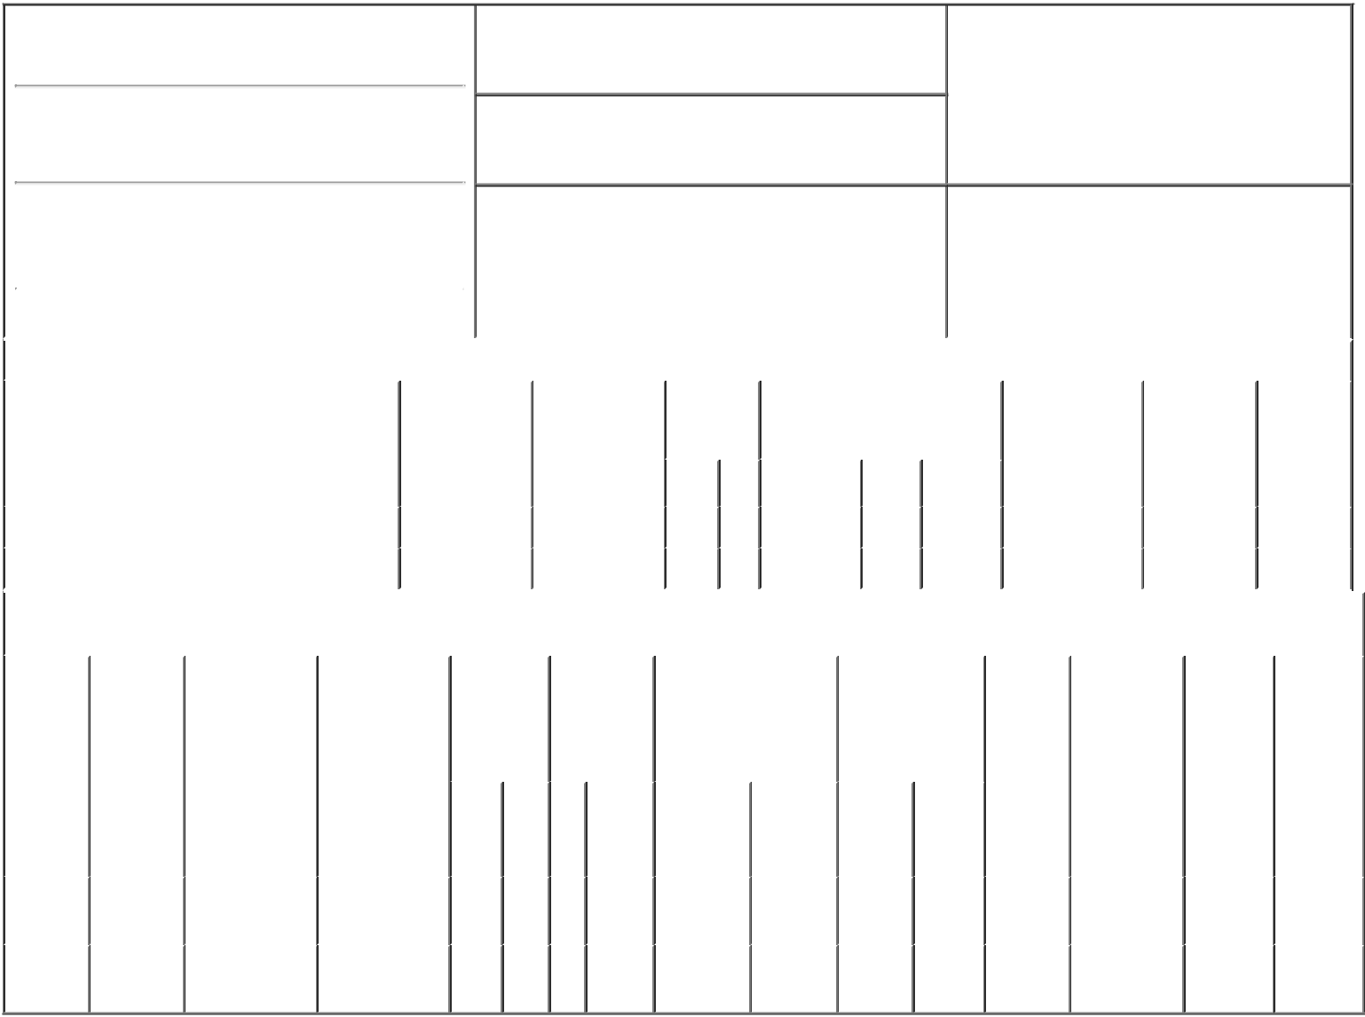

1. Name and Address of Reporting Person*
Regan Timothy

(Last) (First) (Middle)

333 BRANNAN STREET

2. Issuer Name and Ticker or Trading Symbol

DROPBOX, INC. [ DBX ]

3. Date of Earliest Transaction (Month/Day/Year)

05/15/2018

- Relationship of Reporting Person(s) to Issuer (Check all applicable)

 | Director | 10% Owner
X | Officer (give title | Other (specify
 | below) | below)

Chief Accounting Officer

 | (Street) |  |  |  |  |  |  | 4. If Amendment, Date of Original Filed (Month/Day/Year) |  |  |  |  |  | 6. Individual or Joint/Group Filing (Check Applicable
 |  | SAN |  |  |  |  |  |  |  |  |  |  |  | Line)
 |  |  |  | CA |  | 94107 |  |  |  |  |  |  |  | X Form filed by One Reporting Person
 |  | FRANCISCO
 |  |  |  |  |  |  |  |  |  |  |  |  |  |  |  |  | Form filed by More than One Reporting
 |  |  |  |  |  |  |  |  |  |  |  |  |  |  |  |  | Person
 |  | (City) |  | (State) |  | (Zip)
 |  |  |  |  | Table I - Non-Derivative Securities Acquired, Disposed of, or Beneficially Owned
 | 1. Title of Security (Instr. 3) |  |  |  |  | 2. Transaction |  |  | 2A. Deemed | 3. |  | 4. Securities Acquired (A) or |  |  |  |  | 5. Amount of |  | 6. Ownership |  | 7. Nature of
 |  |  |  |  |  | Date |  |  | Execution Date, |  | Transaction | Disposed Of (D) (Instr. 3, 4 and 5) |  |  |  |  | Securities |  | Form: Direct |  | Indirect
 |  |  |  |  |  | (Month/Day/Year) |  |  | if any |  | Code (Instr. |  |  |  |  |  | Beneficially |  | (D) or Indirect |  | Beneficial
 |  |  |  |  |  |  |  |  | (Month/Day/Year) | 8) |  |  |  |  |  |  | Owned Following |  | (I) (Instr. 4) |  | Ownership
 |  |  |  |  |  |  |  |  |  |  |  |  |  |  |  |  | Reported |  |  |  | (Instr. 4)
 |  |  |  |  |  |  |  |  |  |  | Code V | Amount | (A) or | Price |  |  | Transaction(s)
 |  |  |  |  |  |  |  |  |  |  |  |  | (D) |  |  |  | (Instr. 3 and 4)
 | Class A Common Stock |  |  |  |  | 05/15/2018 |  |  |  |  | F | 1,089⁽¹⁾ | D | $29.96 |  |  | 78,362⁽²⁾ |  |  | D
 | Class A Common Stock |  |  |  |  | 05/15/2018 |  |  |  |  | C | 4,088 | A | $0.00⁽³⁾ |  |  | 82,450⁽²⁾ |  |  | D
 |  |  |  |  |  | Table II - Derivative Securities Acquired, Disposed of, or Beneficially Owned
 |  |  |  |  |  | (e.g., puts, calls, warrants, options, convertible securities)
 | 1. Title of |  | 2. |  | 3. Transaction | 3A. Deemed | 4. |  | 5. Number of | 6. Date Exercisable and |  |  | 7. Title and |  |  | 8. Price of |  | 9. Number of |  | 10. | 11. Nature
 | Derivative |  | Conversion |  | Date | Execution Date, | Transaction |  | Derivative | Expiration Date |  |  | Amount of |  |  | Derivative |  | derivative |  | Ownership of Indirect
 | Security |  | or Exercise |  | (Month/Day/Year) | if any | Code (Instr. |  | Securities | (Month/Day/Year) |  |  | Securities |  |  | Security |  | Securities |  | Form: | Beneficial
 | (Instr. 3) |  | Price of |  |  | (Month/Day/Year) | 8) |  | Acquired (A) |  |  |  | Underlying |  |  | (Instr. 5) |  | Beneficially |  | Direct (D) | Ownership
 |  |  | Derivative |  |  |  |  |  | or Disposed |  |  |  | Derivative Security |  |  |  |  | Owned |  | or Indirect | (Instr. 4)
 |  |  | Security |  |  |  |  |  | of (D) (Instr. |  |  |  | (Instr. 3 and 4) |  |  |  |  | Following |  | (I) (Instr. 4)
 |  |  |  |  |  |  |  |  | 3, 4 and 5) |  |  |  |  |  |  |  |  | Reported
 |  |  |  |  |  |  |  |  |  |  |  |  |  |  |  |  |  | Transaction(s)
 |  |  |  |  |  |  |  |  |  |  |  |  |  | Amount |  |  |  | (Instr. 4)
 |  |  |  |  |  |  |  |  |  |  |  |  |  | or
 |  |  |  |  |  |  |  |  |  |  |  |  |  | Number
 |  |  |  |  |  |  |  |  |  | Date |  | Expiration |  | of
 |  |  |  |  |  |  | Code V |  | (A) (D) | Exercisable |  | Date | Title | Shares
 | Class B |  | (4) |  |  |  |  |  | 2,162⁽¹⁾ | (5) |  | (4) | Class A | 2,162 |  |  |  | 66,588⁽⁵⁾
 | Common |  |  |  | 05/15/2018 |  |  | F |  |  |  |  | Common |  |  |  | $29.96 |  |  | D
 | Stock |  |  |  |  |  |  |  |  |  |  |  | Stock
 | Class B |  | (3) |  |  |  |  |  |  | (3) |  | (3) | Class A | 4,088 |  |  |  | 62,500⁽⁵⁾
 | Common |  |  |  | 05/15/2018 |  |  | C | 4,088 |  |  |  | Common |  |  |  | $0.00 |  |  | D
 | Stock |  |  |  |  |  |  |  |  |  |  |  | Stock

Explanation of Responses:

- Represents shares that have been withheld by the Issuer to satisfy income tax withholding and remittance obligations in connection with the vesting and net settlement of restricted stock units previously reported.

- Certain of these securities are restricted stock units. Each restricted stock unit represents the Reporting Person's right to receive one share of Class A Common Stock, subject to the applicable vesting schedule through February 15, 2022. In the event the Reporting Person ceases to be a Service Provider, any then unvested restricted stock units will be cancelled by the Issuer.

- 4,088 shares of Class B Common Stock were converted into 4,088 shares of Class A Common Stock at the election of the Reporting Person and had no expiration date.

- The Issuer's Class B Common Stock is convertible into the Issuer's Class A Common Stock on a one-for-one basis at the Reporting Person's election and has no expiration date.

- These securities are restricted stock units. Each restricted stock unit represents the Reporting Person's right to receive one share of Class B Common Stock, subject to the applicable vesting schedule through November 15, 2020. In the event the Reporting Person ceases to be a Service Provider, any then unvested restricted stock units will be cancelled by the Issuer.

Remarks:

/s/ Bart E. Volkmer, Attorney- |  |  | 05/17/2018
In-Fact
** Signature of Reporting Person |  |  | Date

Reminder: Report on a separate line for each class of securities beneficially owned directly or indirectly.

* If the form is filed by more than one reporting person, see Instruction 4 (b)(v).

- Intentional misstatements or omissions of facts constitute Federal Criminal Violations See 18 U.S.C. 1001 and 15 U.S.C. 78ff(a). Note: File three copies of this Form, one of which must be manually signed. If space is insufficient, see Instruction 6 for procedure.
Persons who respond to the collection of information contained in this form are not required to respond unless the form displays a currently valid OMB Number.

